CS 3345 Project 4

Red-Black tree

Sample output:

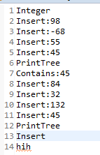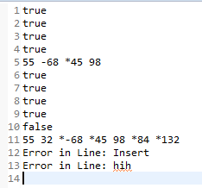

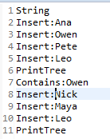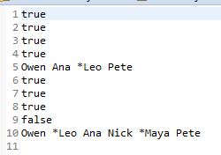

The Zip file contains 2 java files. The RedBlackTree is the tree and the theMain contain the Main function.